Fall, 2018 - ITEC 3150 MidTerm Exam

Complete 3 of the 4 problems listed. You may complete the 4th for extra credit, but partial credit will be given to no more than 3 problems. Coding standards are not graded, but make sure your file is readable if you want partial credit. Turn in EVERY .java or data file needed to make your program compile and run even if it is a duplicate of one given to you. You may turn in individual files or zip up the results and attach to the Assignment box. I suggest turning in answers as you complete a problem.

1. **Binary File I/O: Files Needed: Pet.java – 33 pts**

Create a class with a main that instantiates three instances of the Pet class. (Pet.java is attached to the Assignment box. The three pets should have the following attributes as shown in the table below. DO NOT MODIFY Pet.JAVA!!!! Create a new class that uses the one I gave you. DO turn in Pet.java.

|  |  |  |
| --- | --- | --- |
| **Owner** | **Age** | **Name** |
| Superman | 500 | Spot |
| Batman | 10 | Rover |
| Aquaman | 7 | Fish |

In the main, create an output file named *names.dat* with **DataOutputStream** and write the attributes of each Person instance to the output file. Place the file in the default directory. (ie do NOT specify a specific directory- just a file name).

1. **Java FX : no files provided – 33 pts**

Recreate the GUI shown below using JavaFX libraries. Turn in any .java files you use to recreate it. DO NOT USE A GUI BUILDER- BUILD WITH CODE. Try to match the placement of the items as closely as possible.

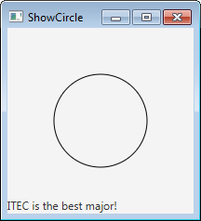

**3) JavaFX – no file provided – 33 pts**

Create a GUI that looks like the following: (Hint: I used BorderPane and set stage size to 200, 200) (no code provided)

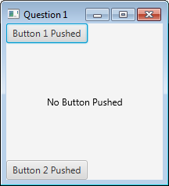

When Button 1 is pushed, the text in the center should change like so:

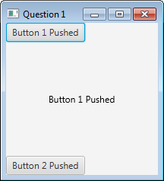

**4. Binary File – Files needed Game.java, WriteGame.java, games.dat (data file)– 33 pts**

Given the file Game.java (attached) and WriteGame.java. WriteGame writes a series of Game objects to a file named games.dat. Write a separate Java class with a main that reads and prints ALL the Game objects from games.dat

DO NOT MODIFY Game.java or games.dat. Do turn in Game.java and the Java class you create.